Club Name:
Body/Head Map

Student Name:
Date:

This form is to be used in conjunction with the Safeguarding Reporting Form, when an injury is visible. Circle the body area name or mark the area on the image affected.

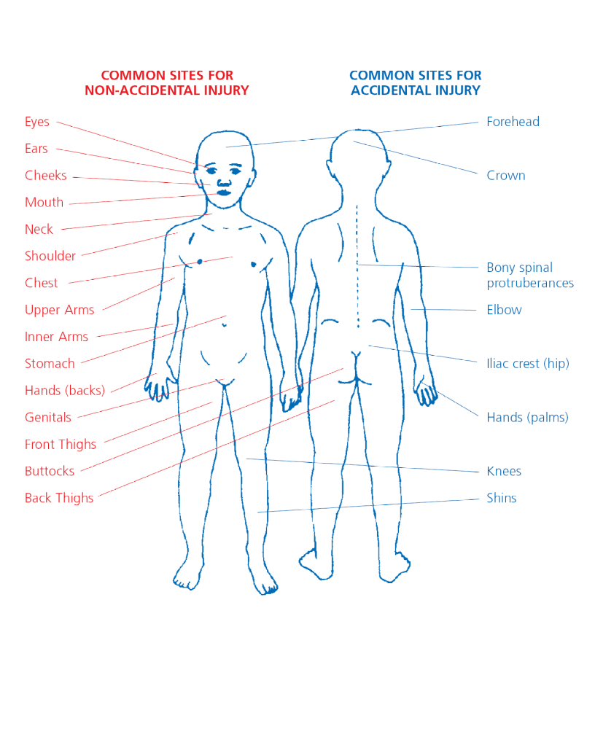

Club Name
Head Map

Student Name:
Date:

This form is to be used in conjunction with the Safeguarding Reporting Form, when an injury is visible. Circle the body area name or mark the area on the image affected.



